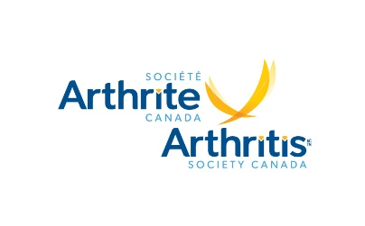
Accessibility for Ontarians with Disabilities Act (AODA) Feedback Form
Arthritis Society Canada strives to provide services that are accessible to all persons in compliance with the Accessibility for Ontarians with Disabilities Act. We recognize that receiving feedback provides a valuable opportunity to learn and improve.
- Date of visit: Click here to enter a date. Time of Visit: Click or tap here to enter text.

- Location of visit: Select location
3. Did we respond to your needs? ☐ Yes ☐ No
If No, please explain:

3. Was our service provided to you in an accessible manner? ☐ Yes ☐ No
If No, please explain:

4. Optional information - complete only if you wish to be contacted by Human Resources.
Preferred contact method:
☐ Telephone: ext.

☐ In Person: Select Location
☐ Email:

☒ Mail:
Name:

Address:

City: Postal Code:

Please complete the Feedback Form and email the form to accessibility@arthritis.ca. If you have questions, call our HR Department at 416-979-7228 or email hr@arthritis.ca. All feedback is directed to HR and responses will follow within 5 business days.

Arthritis Society Canada is committed to keeping your personal information accurate, confidential, secure and private. Please visit https://arthritis.ca/about-us/policies-en/privacy-policy to learn how we collect, use, disclose and safeguard your personal information.

